**Interfacing Seven Segment Display to 8051**

**Lab #05**



Spring 2022

CSE-307L Microprocessor Based system Design

Submitted by: **Ashfaq Ahmad**

Registration No: **19PWCSE1795**

Class Section: **B**

“On my honor, as student of University of Engineering and Technology, I have neither given nor received unauthorized assistance on this academic work.”

Student Signature: ______________

Submitted to:

**Dr: Aber Irfan sab**

**August** 2, 2022

**Department of Computer Systems Engineering**

**University of Engineering and Technology, Peshawar**

**Task 01:** Display 0-9 on Seven Segment Display.

**Source Code:**

org 000h

start:

Mov P2,#3FH

acall delay

Mov P2,#06H

acall delay

Mov P2,#5BH

acall delay

Mov P2,#4FH

acall delay

Mov P2,#66H

acall delay

Mov P2,#6DH

acall delay

Mov P2,#7DH

acall delay

Mov P2,#07H

acall delay

Mov P2,#7FH

acall delay

Mov P2,#6FH

acall delay

sjmp start

delay:

Mov R1,#250

loop1:

Mov R2,#250

loop2:

    NOP

    NOP

    DJNZ R2,loop2

    DJNZ R1,loop1

ret

end

**Output:**

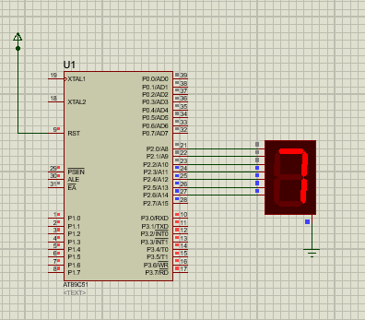

**Task02:** Write a program to count up to 00-99 using seven segment displays using with single port.

**Source Code:**

org 000h

start:

    MOV A,#0

    mov R1,#10

TEN:

    mov R2,#10

UNIT1:

    MOV P2,A

    ADD A,#1

    acall DELAY

    DJNZ R2,UNIT1

    ADD A,#6     ;After each 10 digit add 6 to convert hex to decimal

    DJNZ R1,TEN

LJMP start

DELAY:

 MOV R4,#255

AGAIN:

 MOV R5,#255

HERE:

 NOP

 NOP

 DJNZ R5,HERE

 DJNZ R4,AGAIN

 RET

END

**Output:**

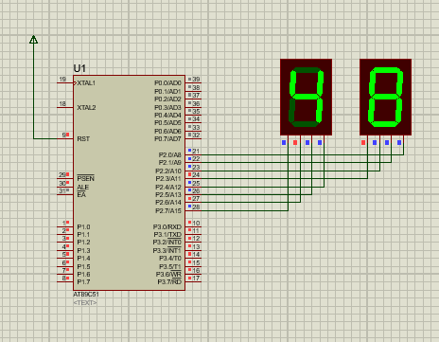

**Task03:** Write a program to count up to 0000-9999 using seven segment displays using with single port.

**Source Code:**

#include <reg51.h>

#include <stdio.h>

int Array[10] = {0x3F,0x06,0x5B,0x4F,0x66,0x6D,0x7D,0x07,0x7F,0x6F};

int cnt,num,temp,i;

void Delay(unsigned int time)

{

         unsigned int x,y;

         for(x = 0;x<time;x++)

         for(y = 0;y<123;y++);

}

void main(void)

{

    while (1)

    {

        for (cnt = 0; cnt <= 9999; cnt++)

        {

            for (i = 0; i < 20; i++)

            {

                        num = cnt;

                        temp = num / 1000;

                        num = num % 1000;

                        P3 = 0xFE;

                        P2 = Array[temp];

                        Delay(1);

                        temp = num / 100;

                        num = num % 100;

                        P3 = 0xFD;

                        P2 = Array[temp];

                        Delay(1);

                        temp = num / 10;

                        P3 = 0xFB;

                        P2 = Array[temp];

                        Delay(1);

                        temp = num % 10;

                        P3 = 0xF7;

                        P2 = Array[temp];

                        Delay(1);

            }

        }

    }

}

**Output:**

